**LAB-EVALUATION**

NAME :KV.SRIDHAR SAI

ROLL-NO : CB.EN.U4CSE19063

DATE : 29-08-2020

SET : 2

QUESTION-1

package com.amritalab;  
  
import java.util.Arrays;  
import java.util.Scanner;  
  
public class question1 {  
 public static void main(String[] args){  
 System.*out*.println("please enter the size of array :");  
 Scanner input = new Scanner(System.*in*);  
 int n = input.nextInt();  
 int inputs[] = new int[n];  
 int i = 0;  
 for ( i = 0 ; i < n ;i++)  
 {  
 inputs[i] = input.nextInt();  
 }  
 double cummavg[] = new double[n];  
 double sum = 0;  
 for (i = 0;i < n;i++)  
 {  
 sum = sum + inputs[i];  
 cummavg[i] = sum / (i+1);  
 }  
 System.*out*.println(Arrays.*toString*(cummavg));  
 }  
}

output :

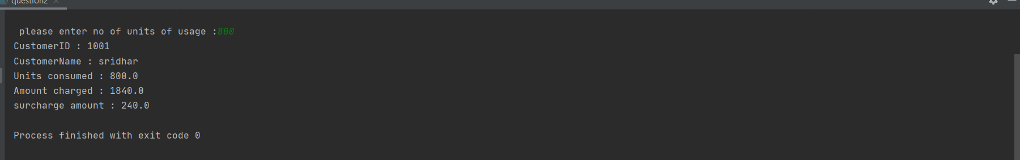

QUESTION - 2

package com.amritalab;  
  
import java.util.Scanner;  
  
public class question2 {  
 public static void main(String[] args){  
 Long custID;  
 Scanner input = new Scanner(System.*in*);  
 System.*out*.print("Please enter your Customer_Id : ");  
 custID = input.nextLong();  
 System.*out*.print(" \n Please enter your name : ");  
 String name ;  
 name = input.next();  
 float units;  
 System.*out*.print("\n please enter no of units of usage :");  
 units = input.nextFloat();  
 double rate = 0;  
 if (units <= 199)  
 {  
 rate = (units * 1.20);  
 }  
 else if (units >= 200 && units < 400)  
 {  
 rate = (units * 1.50);  
 }  
 else if (units >= 400 && units < 600)  
 {  
 rate = (units * 1.80);  
 }  
 else if (units > 600)  
 {  
 rate = (units * 2);  
 }  
 double surcharge = 0;  
 if (rate > 400)  
 {  
 surcharge = (rate * 0.15);  
 rate = rate + surcharge;  
 }  
 System.*out*.println("CustomerID : " +custID);  
 System.*out*.println("CustomerName : "+name);  
 System.*out*.println("Units consumed : " + units);  
 System.*out*.println("Amount charged : " + rate);  
 System.*out*.println("surcharge amount : " +surcharge);  
  
 }  
}

OUTPUT :

